Architecture Diagram:
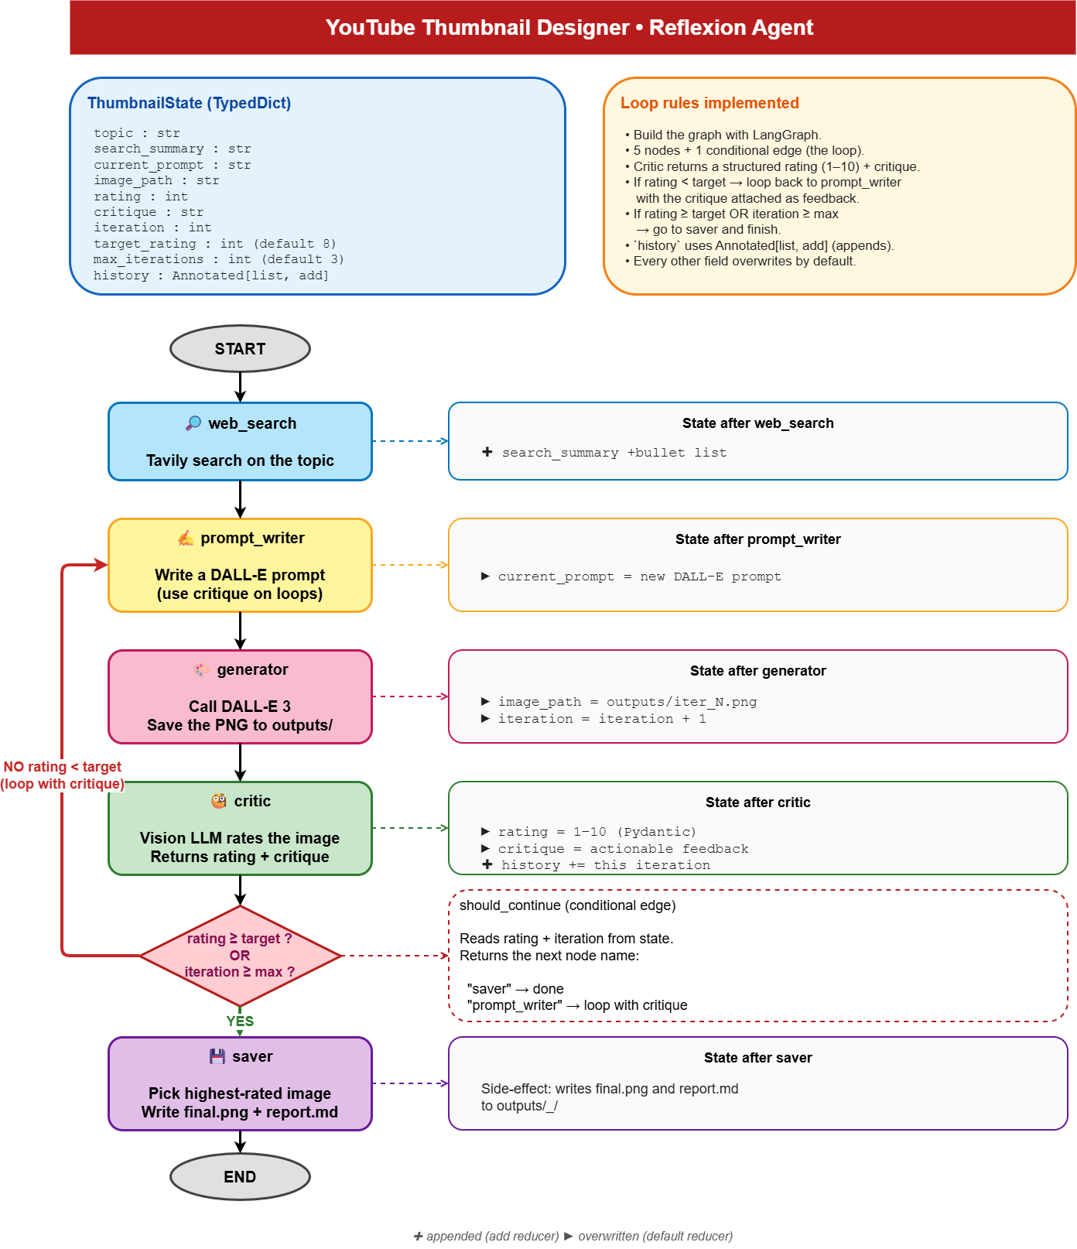

Run the Thumbnail Designer for Topic “Future of AI = AI Agents”:

python -m ytb_thumb_design_agent.main "Future of AI = AI Agents"
Run complete
Output dir: outputs\20260520_183131_future-of-ai-ai-agents
Best rating: 8
Final image: outputs\20260520_183131_future-of-ai-ai-agents\final.png
Report: outputs\20260520_183131_future-of-ai-ai-agents\report.md
(.venv) PS D:\Data Science\DataSense\Code\youtube_thumbnail_designer>

Iteration 1:
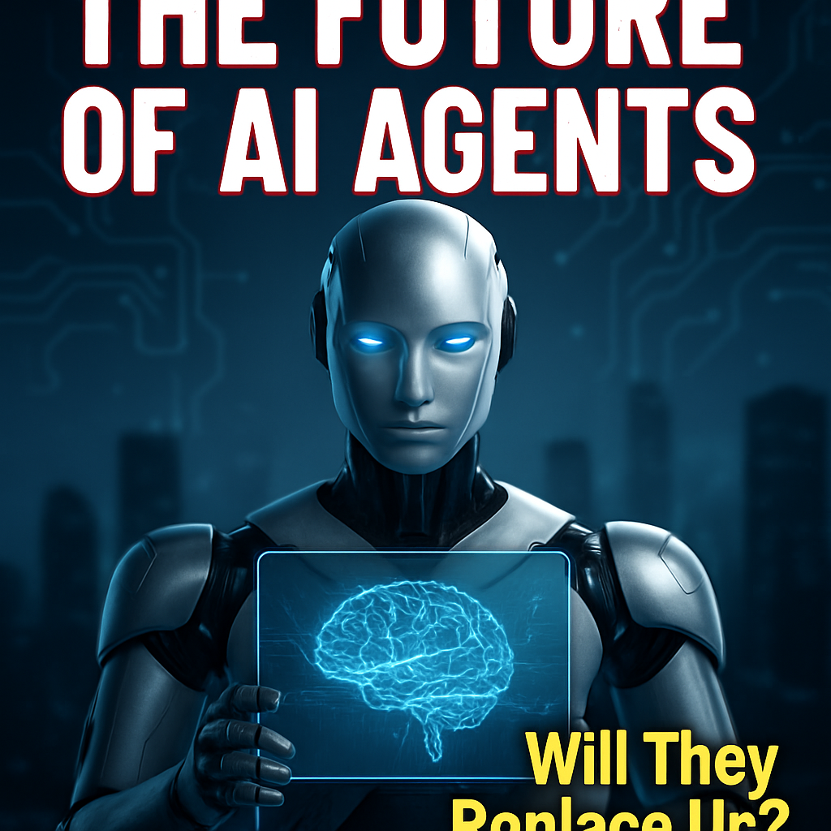

Iteration 2:
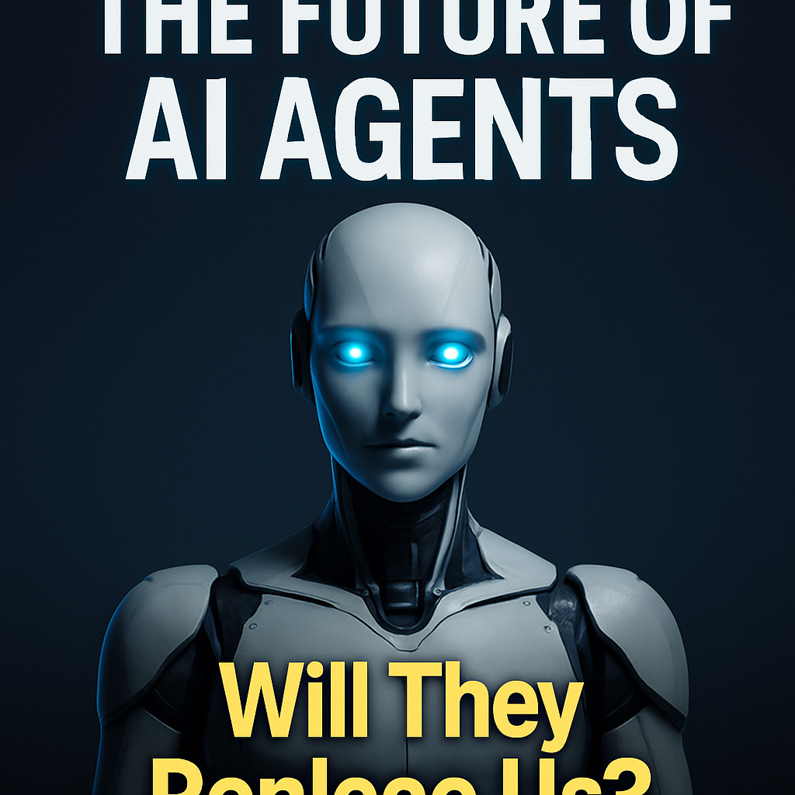

Iteration 3:
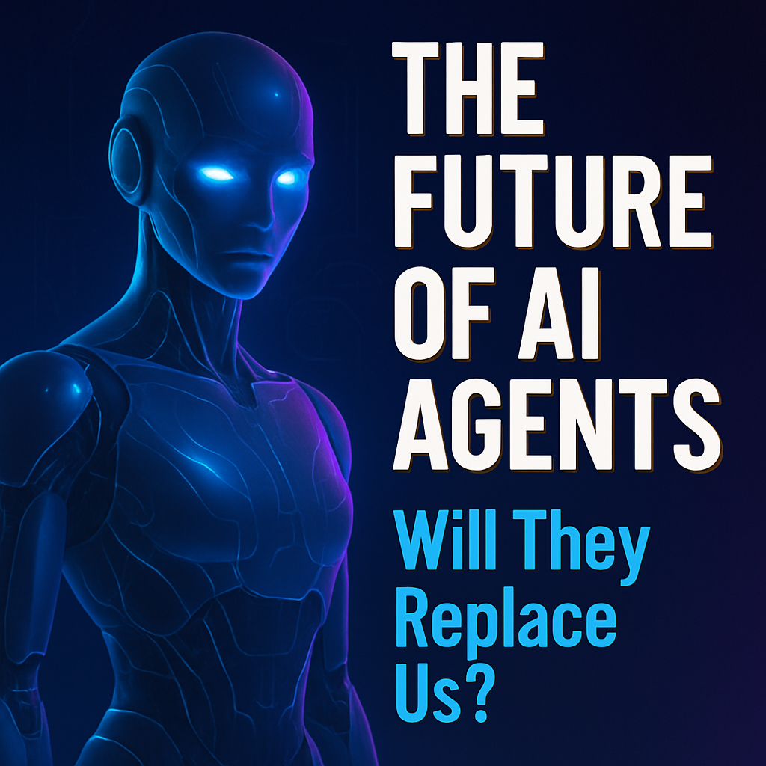

Final:


Snapshot of report.md
Thumbnail Run Report
- Topic: Future of AI = AI Agents
- Target rating: 8
- Max iterations: 3
- Completed iterations: 3
- Best rating: 8
- Final image: final.png
Search summary
- 10 Viral AI YouTube Thumbnail Styles for More Views in 2026 | https://miraflow.ai/blog/ai-youtube-thumbnail-styles-more-views-2026 “Top 3 Tools” “My AI Stack” “Best 5 Tips” ## 10. Mystery Silhouette & Question (Curiosity Hooks) mysterious-shadow.png For more “what is this?” style videos: Silhouette or blurred subject Question mark or mysterious highlight Darker subject, but still readable on a lightish background Strong curiosity in the text Why it works Suggests something hidden or surprising. Encourages the cl
- Best YouTube Hook Generator Tools in 2026 | https://www.overseeros.com/blog/best-youtube-hook-generator-tools Do not use this workflow: Ask AI for a hook Pick the one that sounds dramatic Paste it into the script Publish Use this instead. ### Step 1: Start With the Title Promise The hook must continue the title promise. Title: I Tested 12 AI Tools for YouTube. Only 4 Were Useful. Bad hook: AI is changing the future of content creation. Good hook: ``` I tested 12 AI too
- AI Thumbnail Generator Templates for YouTube and Blogs | MindStudio | https://www.mindstudio.ai/blog/ai-thumbnail-generator-templates-youtube-blogs/ Build feedback loops between creation and performance. When thumbnails succeed or fail, understand why. Document insights. Adjust your AI prompts, templates, and selection criteria based on real-world results. ## The Future of AI Thumbnail Generation AI thumbnail technology is evolving rapidly. Here’s what’s coming next. ### Predictive Performance Optimization Future tools will predict perform
- AI comes for YouTube’s thumbnail industry - Rest of World | https://restofworld.org/2023/youtube-thumbnail-ai/
Explore by #### Beats #### Regions #### Sections #### Learn more #### Follow us #### Dark Mode The Rise of AI # AI comes for YouTube’s thumbnail industry Creators like MrBeast pay up to $10,000 for a single YouTube video thumbnail, but the rise of AI tools has some designers anxious about the microeconomy’s future. A illustration of a Youtube play button within a decorative gold fr
- 10 AI Agents for Content Creators and YouTubers - MindStudio | https://www.mindstudio.ai/blog/ai-agents-for-content-creators/ The most sophisticated thumbnail agents use multimodal AI to analyze your video content and suggest thumbnails based on the most engaging moments. They review your footage, identify emotional peaks, and generate thumbnails that accurately represent your content. You can build a thumbnail workflow in MindStudio that generates options, runs tests, and updates your video automatically when a winner
Iteration history
Iteration 1
- Image: iter_1.png
- Rating: 7/10
- Critique: The thumbnail effectively uses a futuristic robot image to convey the topic of AI agents, which is visually engaging and relevant. The text "THE FUTURE OF AI AGENTS" is clear and bold, making it easy to read even at smaller sizes. The question "Will They Replace Us?" adds an intriguing element that could entice viewers to click.
However, the text at the bottom is slightly less readable due to its smaller size and color contrast against the background. The overall composition is strong, but the background could be simplified to reduce visual noise and enhance focus on the main elements.
- Strengths: Clear and bold main text, Engaging and relevant imagery, Intriguing question adds interest
- Improvements: Increase contrast for bottom text, Simplify background to reduce noise
Prompt used
A futuristic humanoid robot with glowing blue eyes, front and center, holding a transparent digital tablet displaying a holographic AI brain; the robot’s face is sharply lit with cool white and blue lighting to create high contrast against a dark, blurred cityscape background with neon circuit patterns subtly glowing; bold, large white text with a bright red outline reading “THE FUTURE OF AI AGENTS” positioned in the top third, left-aligned for easy mobile readability; below, in smaller yellow text with black shadow, “Will They Replace Us?” placed near the bottom right corner; composition uses shallow depth of field to keep focus on the robot and text, ensuring crisp legibility on small screens; overall mood is mysterious and intriguing, inviting curiosity without clutter.
Iteration 2
- Image: iter_2.png
- Rating: 7/10
- Critique: The thumbnail effectively uses a futuristic robot image to convey the topic of AI agents, which is visually engaging and relevant. The text is clear and readable, with a strong contrast against the dark background. The question "Will They Replace Us?" adds an emotional pull and curiosity factor, encouraging clicks.
However, the composition could be improved by slightly reducing the size of the robot to create more breathing space around the text, enhancing overall balance. Additionally, incorporating a subtle visual element that hints at the future or technology could further strengthen the theme.
- Strengths: Clear and readable text, Strong contrast, Engaging and relevant imagery, Emotional and curiosity-inducing question
- Improvements: Reduce robot size for better composition, Add a subtle futuristic or tech element
Prompt used
A sleek, humanoid AI robot with glowing blue eyes centered prominently in the frame, facing forward with a confident, slightly curious expression; behind it, a smooth, dark gradient background fading from deep navy at top to black at the bottom to minimize distractions and enhance focus on the robot; bold, all-caps white text reading “THE FUTURE OF AI AGENTS” positioned at the top third in a large, sans-serif font with a subtle electric blue outline for high contrast; below the robot’s chest, a large, bright yellow question “Will They Replace Us?” in bold, clear font with a soft black drop shadow to ensure legibility on mobile devices; dramatic, focused cool-toned lighting illuminating the robot’s face and upper torso, creating sharp highlights and soft shadows to add depth and intensity; overall mood is mysterious and thought-provoking, with a clean, uncluttered composition emphasizing the central figure and text for maximum impact on small smartphone screens.
Iteration 3
- Image: iter_3.png
- Rating: 8/10
- Critique: This thumbnail is visually striking and effectively communicates the topic. The futuristic AI figure is eye-catching and relevant, drawing immediate attention. The text is clear, with a strong hierarchy that makes it readable even at smaller sizes. The color contrast between the text and background enhances readability, and the question posed adds an element of intrigue, encouraging clicks. The composition is balanced, with the AI figure and text complementing each other well.
- Strengths: Eye-catching AI figure, Clear and readable text, Strong color contrast, Intriguing question
- Improvements: Consider adding a subtle background element to enhance depth
Prompt used
A sleek, semi-transparent futuristic humanoid robot standing slightly off-center left, reduced in size to occupy about 60% width for balanced negative space; the robot’s glowing blue eyes and subtle circuit patterns softly illuminated by cool neon blue and purple lighting to evoke advanced technology and a mysterious future; on the right side, large bold white text outlined in deep navy reading “THE FUTURE OF AI AGENTS” stacked in three lines, with a bright yellow shadow for maximum contrast and legibility on mobile; below that, smaller but still bold text in vivid cyan saying “Will They Replace Us?” aligned left under the main title for emotional intrigue; the background is a sleek dark gradient fading from deep indigo at top to black at bottom, overlaid with a faint, stylized holographic grid and subtle circuit motifs in low opacity to hint at digital futurism without clutter; overall mood is tense curiosity and high-tech wonder, with crisp contrast between glowing elements and dark background ensuring text and subject remain readable on small phone screens.

Run the Thumbnail Designer for Topic “Why Everyone Is Talking About AI Agents”:

(.venv) PS D:\Data Science\DataSense\Code\youtube_thumbnail_designer> python -m ytb_thumb_design_agent.main "Why Everyone Is Talking About AI Agents"
Run complete
Output dir: outputs\20260520_182039_why-everyone-is-talking-about-ai-agents
Best rating: 8
Final image: outputs\20260520_182039_why-everyone-is-talking-about-ai-agents\final.png
Report: outputs\20260520_182039_why-everyone-is-talking-about-ai-agents\report.md
(.venv) PS D:\Data Science\DataSense\Code\youtube_thumbnail_designer>

Iteration 1:

Final:

Snapshot of report.md
Thumbnail Run Report
- Topic: Why Everyone Is Talking About AI Agents
- Target rating: 8
- Max iterations: 3
- Completed iterations: 1
- Best rating: 8
- Final image: final.png
Search summary
- This Tiny AI Agent Writes My Titles and Thumbnails | https://www.youtube.com/watch?v=DR7WLAwAdyo Hi, fellow YouTube content creators. Do you ever feel like you're really struggling with your titles, thumbnails, and hooks, creating them? You have a rough idea of how you want to create, but then again, when it comes to titles, thumbnails, you get just stuck. I've had that problem. Same thing, same problems. And every time I would try to write a compelling title and thumbnail and ideate my episo
- 50+ YouTube Video Hooks & Hook Ideas (2026) | OpusClip | https://www.opus.pro/research/best-video-hooks-youtube "variableMeasured": ["clips", "avg_views", "avg_likes"]}, {"@context": " "@type": "ItemList", "name": "Top Hook Ideas: Best Video Hooks for YouTube", "numberOfItems": 48, "itemListElement": [{"@type": "ListItem", "position": 1, "name": "Have you ever wondered why [topic] actually works?"}, {"@type": "ListItem", "position": 2, "name": "What if everything you know about [topic] is wrong?"}, {"@typ
- 10 AI Agents for Content Creators and YouTubers | MindStudio | https://www.mindstudio.ai/blog/ai-agents-for-content-creators/
Seven tools to build an app. Or just Remy. Editor, preview, AI agents, deploy — all in one tab. Nothing to install. Remy Thumbnail agents handle two critical tasks: design and testing. On the design side, they generate multiple thumbnail variations using AI image generation. On the testing side, they run A/B tests to determine which thumbnails drive the most clicks. Research shows that crea
- 30 AI YouTube Video Ideas That Get Views Quickly in 2026 – Packapop | https://packapop.com/blogs/youtube-success-blog/ai-youtube-video-ideas?srsltid=AfmBOopTuXWflVr9njq9GRxC00vBzCITEnxJYxrbm_usdH3cCmDgmwy6 Why it works: Dev market + pain relief. Monetization: Dev courses, repo templates, sponsors. Thumbnail cue: Code window + “BUGS → FIXED”. ### 8) “AI for YouTubers” (Titles, Hooks, Thumbnails) Why it works: Creator-to-creator utility. Monetization: Thumbnail templates, coaching, vidIQ affiliate. Thumbnail cue: CTR badge + “+72%”. ### 9) “AI for Social Media” (Shorts, Captions, Carousels)
- AI: Overhyped or Overpromised? | Jamie Dixon posted on the topic | LinkedIn | https://www.linkedin.com/posts/mrjamiedixon_any-ai-experts-care-to-analyse-my-thinking-activity-7377965117902180352-sHOJ Why Everyone Is Talking About AI Agents – And What They Really Are? AI is changing quickly, and you might have heard the term AI Agents a lot lately. But what does it really mean? Let’s take a closer look and explain it in a simple way. What Are AI Agents? An AI Agent is more than a single chatbot answering questions. Think of it as a mini-program where an AI model (like ChatGPT) doesn’t just give
Iteration history
Iteration 1
- Image: iter_1.png
- Rating: 8/10
- Critique: This thumbnail is visually striking and effectively communicates the topic. The expression of surprise on the woman's face adds emotional pull and curiosity, which can attract viewers. The glowing AI figure is eye-catching and relevant to the topic, enhancing the visual appeal. The text is clear, concise, and easy to read, even at smaller sizes. The composition is well-balanced, with a good contrast between the text and background.
- Strengths: Strong emotional appeal, Clear and readable text, Good use of contrast, Relevant and eye-catching imagery
- Improvements: Consider adding a subtle background element related to AI for more context.
Prompt used
A sharply focused, expressive young professional woman with a surprised and intrigued expression, holding a glowing futuristic AI robot figure in her outstretched hand at center-right; bold, large white text overlay on left side reading “Why AI Agents?” with a subtle black shadow for contrast and maximum legibility on mobile; vibrant, high-contrast colors with electric blue and neon orange highlights around the AI figure against a dark, blurred tech-inspired background of circuit patterns and digital code; dramatic, cool-toned lighting illuminating her face and the robot, creating a dynamic glow that draws immediate attention to the AI figure; composition balanced to keep the subject and text clear and uncluttered for strong visual hierarchy and instant click appeal on small phone screens.

Generate the graph diagram
(.venv) PS D:\Data Science\DataSense\Code\youtube_thumbnail_designer>
(.venv) PS D:\Data Science\DataSense\Code\youtube_thumbnail_designer> python -m ytb_thumb_design_agent.make_diagram
Wrote graph visualization to: D:\Data Science\DataSense\Code\youtube_thumbnail_designer\outputs\graph.png
(.venv) PS D:\Data Science\DataSense\Code\youtube_thumbnail_designer>
